Name

Mathematics Stage 4
Expanding Brackets

Book 4 |  | Version: 260930  Feedback:  https://MrDingMaths.com
Contents
Syllabus Content 2
Expanding Brackets 1 3
Expanding Brackets 2 10
Challenge Exercise 16

Syllabus Content
MA4-ALG-C-01 generalises number properties to operate with algebraic expressions including expansion and factorisation
Extend and apply the distributive law to the expansion of algebraic expressions
- Explain the role and meaning of grouping symbols in algebraic expressions
- Apply the distributive law to expand and simplify algebraic expressions by removing grouping symbols

Expanding Brackets 1

- Review
- Simplify algebraic multiplication
- $3×2a$ | - $4×3x$ | - $5\left(2b\right)$ | - $2(4y)$

- Multiply integers
- $3×\left(-4\right)$ | - $5×\left(-2\right)$ | - $3×4$ | - $-2×5$
- $-3\left(-4\right)$ | - $-5\left(-2\right)$ | - $-5\left(4\right)$ | - $-2\left(-3\right)$

- Simplify algebraic multiplication
- $3\left(-2a\right)$ | - $4\left(-3x\right)$ | - $-2\left(3b\right)$ | - $-3\left(4x\right)$
- $-2\left(-3a\right)$ | - $-4\left(-2x\right)$ | - $6\left(-2y\right)$ | - $-12\left(-2xy\right)$

- Multiply grouped terms
Using the diagrams, multiply these grouped terms.
- $3×\left(4+x\right)$  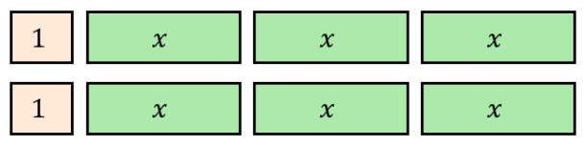  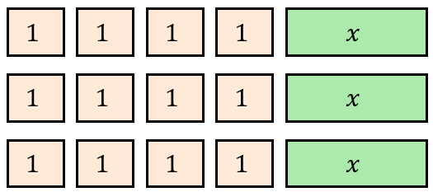 | - $2\left(1+3x\right)$

- Expanding Brackets
We group terms using brackets.
Expanding brackets means simplifying an expression by writing without brackets.
To expand brackets, we multiply each term inside the brackets by the term outside.
This is called the distributive law.

$$a\left(b+c\right)=ab+ac$$

- Example Expand brackets using the distributive law
Expand:
$$3\left(2x+5\right)$$  $$=3\left(2x\right)+3\left(5\right)$$  $$=6x+15$$ | To expand a bracket, multiply e………… term inside the brackets by the term o……………

- Guided Practice
Expand:
- $4\left(3a+2\right)$ | - $4\left(3a-2\right)$ | - $5\left(x-3\right)$
- $-2\left(3x+4\right)$ | - $-3\left(2x-5\right)$ | - $2\left(a+3b+4\right)$

- Key Ideas
- To expand a bracket, multiply …………… term inside the brackets by the term …………… the bracket.
- When there is subtraction inside the brackets, such as $4\left(3a-2\right)$, treat the two terms inside the bracket as ……… and ………

Foundation
- Complete the table.
Expression | Diagram | Expanded Expression
$$3(x+2)$$ | 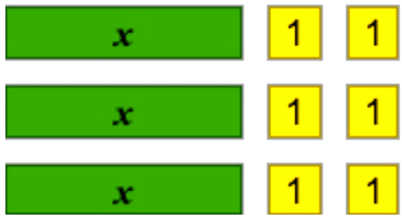 | $$3x+6$$
$$2(x+1)$$ |  | $2x+2$
$$2(x-2)$$ | 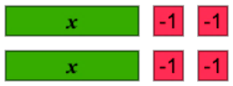 | $2x-4$
$$2(x+4)$$ | 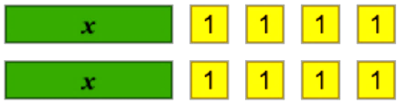 | $2x+8$
$$3(x+1)$$ | 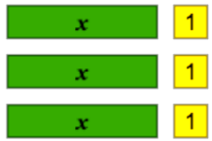 | $3x+3$
$$3(x-2)$$ | 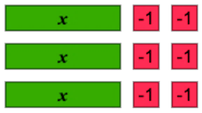 | $3x-6$

- Expand the brackets.
$3x+12$ | $3x-12$ | $6x+12$
$6x-12$ | $6x-15y+12$

- Expand these expressions using the distributive law.
- $6(y+8)$  $6y+48$ | - $8(s+7)$  $8s+56$ | - $-7(x+5)$  $-7x-35$
- $9(x-9)$  $9x-81$ | - $8(y-4)$  $8y-32$ | - $-6(3-e)$  $-18+6e$

- Expand these expressions using the distributive law.
- $10(6g-7)$  $60g-70$ | - $5(7w+10)$  $35w+50$ | - $-7(8x-2)$  $-56x+14$
- $7(q-7)$  $7q-49$ | - $2(2u-6)$  $4u-12$ | - $-6(8l+5)$  $-48l-30$

- The area of a rectangle is $A=length×width.$
Write an expression for the area of these rectangles.
$4\left(2x-5\right)=$ ………………  $8x-20$ | 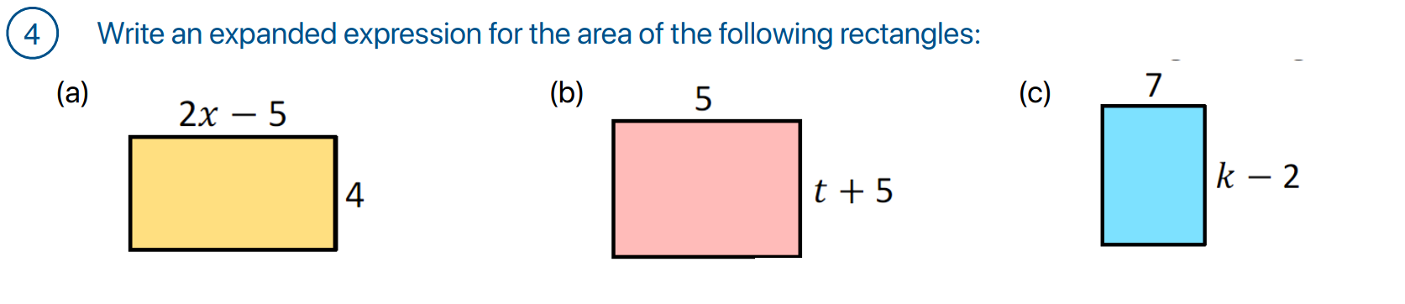  $5t+25$ | $7k-14$

- Expand these brackets.
- $2(2b-3)$  $$4b-6$$ | - $-5(2x+3)$  $$-10x-15$$ | - $2(3x+4)$  $$6x+8$$ | - $-3(2a-5)$  $$-6a+15$$
- $3(4x+2)$  $$12x+6$$ | - $-2(3x+4)$  $$-6x-8$$ | - $4(3a-2)$  $$12a-8$$ | - $-5(2x-3)$  $$-10x+15$$
- $4(3b+5)$  $$12b+20$$ | - $-2(3x-4)$  $$-6x+8$$ | - $5(2x-4)$  $$10x-20$$ | - $-3(2a+5)$  $$-6a-15$$
- $3(2x-5)$  $$6x-15$$ | - $-4(3b+2)$  $$-12b-8$$ | - $5(2a+3)$  $$10a+15$$ | - $-4(3b-2)$  $$-12b+8$$

- The side length of a square is $x+2$. Write an expression for the perimeter.  $4\left(x+2\right) or 4x+8$ | - The side length of a regular hexagon is $2x+5$. Write an expression for the perimeter.  $6\left(2x+5\right) or 12x+30$

Development
- Write an expression for each of the following and then expand it.
  - A number, $x$, has 3 added to it and the result is multiplied by 5.
$5x+15$
  - A number, $b$, has 6 added to it and the result is doubled.
$2b+12$
  - A number, $z$, has 4 subtracted from it and the result is multiplied by 3.
$3z-12$
  - A number, $y$, is subtracted from 10 and the result is multiplied by 7.
$$70-7y$$
- The number of boys in a classroom is $b$ and the number of girls is $g$.
Each boy has 5 pencils and each girl has 3 pencils.
  - Write an expression for the total number of pencils in the class.
$5b+3g$
  - If the pencils cost $2 each, write and expand an expression for the total cost of all the pencils in the room.
$10b+6g$
  - Each boy and girl also has one pencil case, costing $4 each.
Write a simplified and expanded expression for the total cost of all pencils and cases.

$14b+10g$
  - If there are 10 boys and eight girls in the room, what is the total cost for all the pencils and cases in the room?

220
- Complete each pyramid. Each expression is the sum of the two expressions below it.
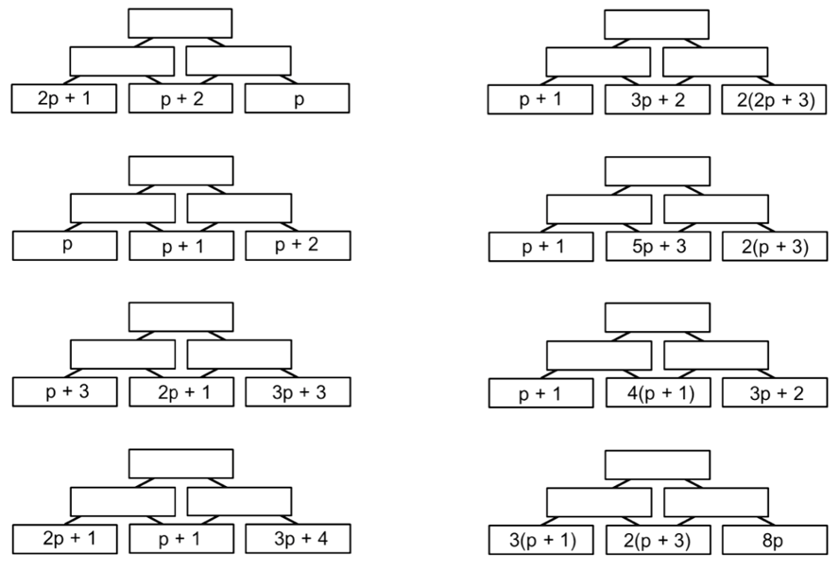  $12p+11$  $5p+5 , 7p+6$ | $11p+11$  $4p+3 , 7p+8$
$15p+15$  $5p+9 , 10p+6$ | $13p+13$  $6p+4 , 7p+9$
- Complete these sequences of operations.
$$+4$$
$$×3$$
$$k+2$$

$k+6 , 3k+18$
$$×3$$
$$+4$$
$$k+2$$

$3k+6 , 3k+10$
$$×2$$
$$+3$$
$$2m+1$$

$4m+2 , 4m+5$
$$+3$$
$$×2$$
$$2m+1$$

$2m+4m , 4m+8$
$$÷3$$
$$+12$$
$$6y+9$$

$2y+3 , 2y+15$
$$+12$$
$$÷3$$
$$6y+9$$

$6y+21 , 2y+7$
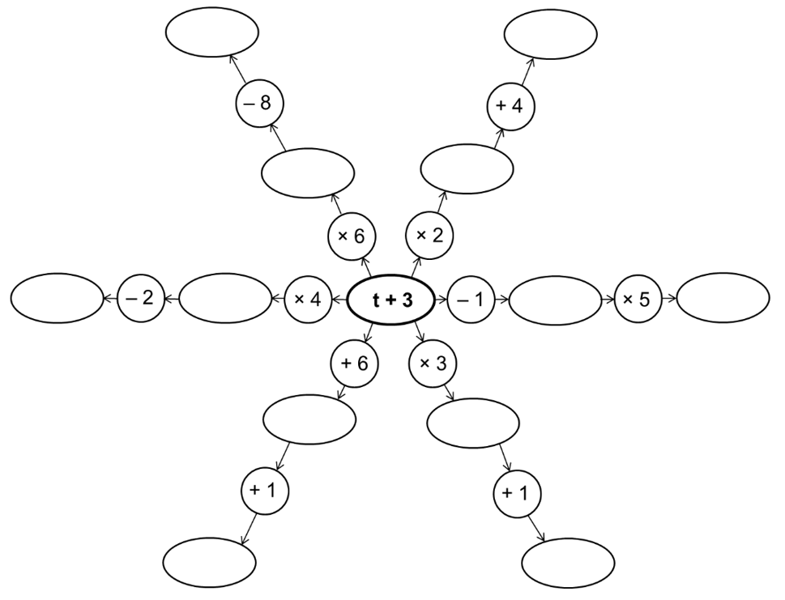
- Start in the middle and work outwards. Fill in the missing expressions.

(outer clockwise from top left): $6t+10 , 2t+10 , 5t+10 , 3t+10 , t+10 , 4t+10$

Mastery
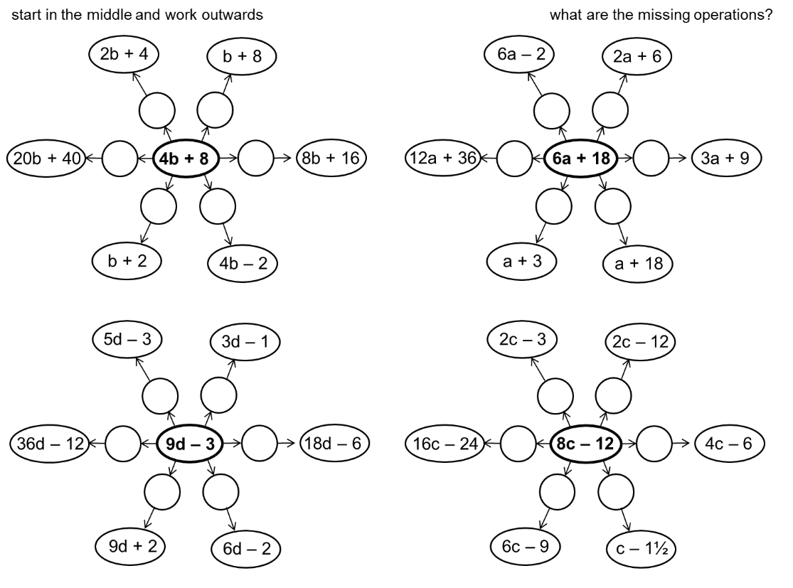
- Start in the middle and work outwards. What are the missing operations?
(clockwise from top left): $÷2, -3b , ×2 , -10 , ÷4 , ×5$ | (clockwise from top left): $÷4 , -6c , ÷2 , ÷8 , ×\frac{3}{4} , ×2$
- Start in the middle and work outwards. What are the missing operations?
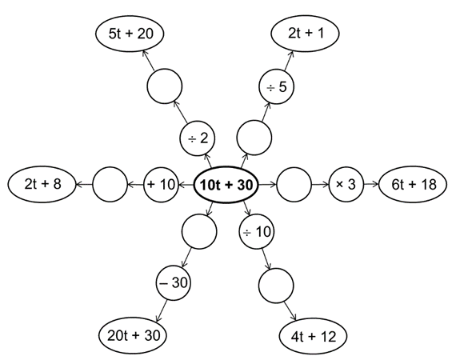

(clockwise from top left): $+5, -25 , ÷5 , ×4 , ×2 , ÷5$

- Expand these expressions involving fractions.
$$\frac{1}{3}\left(6x+15\right)$$  $2x+5$ | $$\frac{1}{4}\left(12x+8y\right)$$  $3x+2y$ | $$\frac{3}{4}\left(16-12y\right)$$  $12-8y$ | $$\frac{4x+10y}{2}$$  $2x+5y$

Expanding Brackets 2

- Review
- Simplify algebraic multiplication
- $x×y$ | - $a×b$ | - $p×q$ | - $x×2y$
- $4y×x$ | - $a×3b$ | - $2p×3q$ | - $x×x$
- $3x×x$ | - $3ab×a$ | - $2xy×y$ | - $5pq×3p$

- Expand brackets
- $3\left(4a-b\right)$ | - $3\left(x-2\right)$ | - $12\left(2x+3\right)$ | - $-2\left(x-y\right)$

- Expanding Brackets
To expand brackets, we multiply each term inside the brackets by the term outside.
$$a\left(b+c\right)=ab+ac$$

- Example Expand brackets using the distributive law
Expand $x\left(2y+3\right)$  $=x\left(2y\right)+x\left(3\right)$  $=2xy+3x$ | To expand a bracket, multiply e………… term inside the brackets by the term o……………
Expand $x\left(x+4\right)$  $=x\left(x\right)+x\left(4\right)$  $=x^{2}+4x$ | When something is multiplied by itself, we write $x×x=$ ……

- Guided Practice
Expand:
- $a\left(3b-2\right)$ | - $x\left(x-5\right)$ | - $2x\left(x+3\right)$
- $3x\left(2x-4\right)$ | - $3xy\left(2x-5y\right)$ | - $-3y\left(4-5y\right)$

- Key Ideas
- To expand a bracket, multiply the …………… term inside the brackets by the term …………… the bracket.
- When we multiply two of the same variable together, we write:
$x×x=$ ………, and $ab×a=$ …………

Foundation
- Read the example carefully and answer the questions.
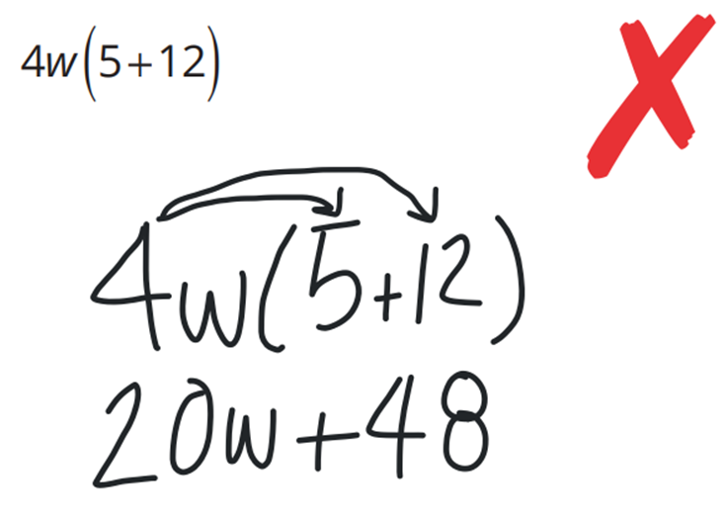  Pablo’s work: | What did Pablo forget when distributing the $4w$?  He forgot to write the …… with 48.  What should Pablo’s final expression be?  $68w$  Expand the following: $4x(3+11)$  $56x$

- Read the examples carefully and answer the questions.
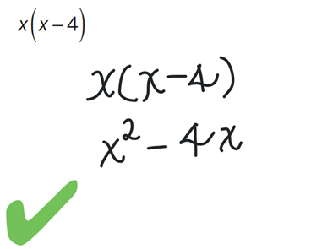  Michael’s work: | Where did $x^{2}$ come from in Michael’s answer?  …… $×$ …… $=x^{2}$  Expand the following: $3x(x-4)$  $3x^{2}-12x$

- Expand the brackets.
$a^{2}+4a$ | $ab+4a$ | $ab-4a$ | $4a-ab$ | $4a-a^{2}$
$3a^{2}-4a$ | $4a-3a^{2}$ | $3a^{2}-12a$ | $6a^{2}-12a$ | $12a-6a^{2}+15ab$

Development
- Expand these brackets.
- $3a(a+2)$  $$3a²+6a$$ | - $x(4y-3)$  $$4xy-3x$$ | - $2x(3x+4)$  $$6x²+8x$$ | - $b(b-2)$  $$b²-2b$$
- $2xy(3x-2y)$  $$6x²y-4xy²$$ | - $a(3b+2)$  $$3ab+2a$$ | - $4x(2x-3)$  $$8x²-12x$$ | - $y(y-4)$  $$y²-4y$$
- $3ab(2a+5)$  $$6a²b+15ab$$ | - $2x(x-5)$  $$2x²-10x$$ | - $a(2b-5)$  $$2ab-5a$$ | - $x(x+3)$  $$x²+3x$$
- $4ab(2a-3b)$  $$8a²b-12ab²$$ | - $2a(5a-4)$  $$10a²-8a$$ | - $x(2y+5)$  $$2xy+5x$$ | - $4a(a-3)$  $$4a²-12a$$
- $2xy(3x+4)$  $$6x²y+8xy$$ | - $a(5+a)$  $$5a+a²$$ | - $3a(2a+5)$  $$6a²+15a$$ | - $2x(4+x)$  $$8x+2x²$$

- Expand these expressions.
- $x(y-3)$  $xy-3x$ | - $d(x+9s)$  $$dx+9ds$$ | - $5a\left(2x+3\right)$  $10ax+15a$
- $5c(2w-4)$  $10cw-20c$ | - $-7y(4x+7)$  $-28xy-49y$ | - $5j(r+7p)$  $5jr+35jp$
- $-8d(t-3d)$  $-8dt+24d^{2}$ | - $-7k(3x+2)$  $-21kx-14k$ | - $14k(y+1)$  $14ky+14k$

- Fill in the empty boxes.
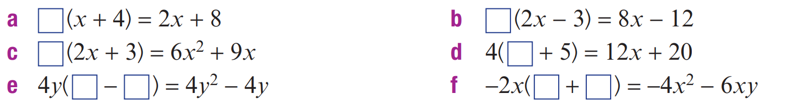  2 | 4
$3x$ | $3x$
$y , 1$ | $2x$ , $3y$

Mastery
- Expand these expressions, then simplify the result.
- $2\left(x+1\right)+3(x+4)$  $5x+14$ | - $3\left(x+4\right)+2\left(x+1\right)$  $5x+14$
- $x\left(x-1\right)+1(x-1)$  $x^{2}-1$ | - $a\left(b+3\right)+2(b+3)$  $ab+3a+2b+6$

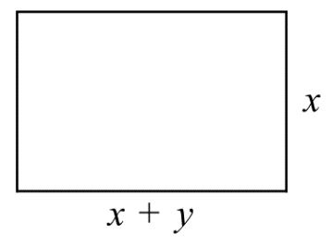
- Write an algebraic expression and expand it to represent the area of the rectangle.

$x^{2}+xy$
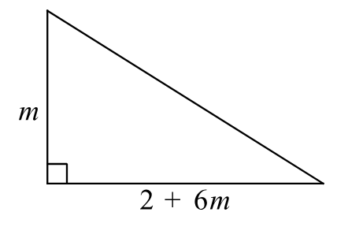
- Write a fully simplified expression to represent the area of the triangle.

$m+3m^{2}$
- Find the area of these shapes in simplest expanded form.
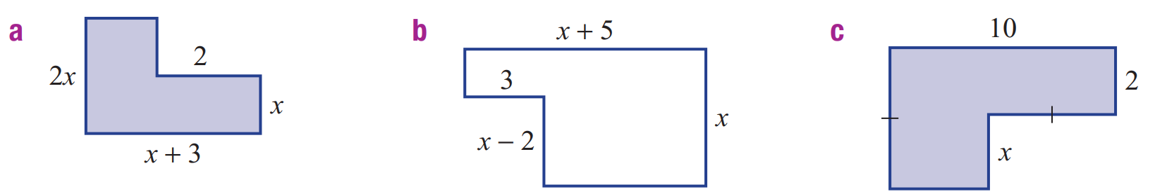  $2x^{2}+4x$ | $6+x^{2}+2x$

- Find expressions, in simplest form, for the perimeter (P) and area (A) of these shapes.
P: $4x-4$  A: $x^{2}-2x-4$ | 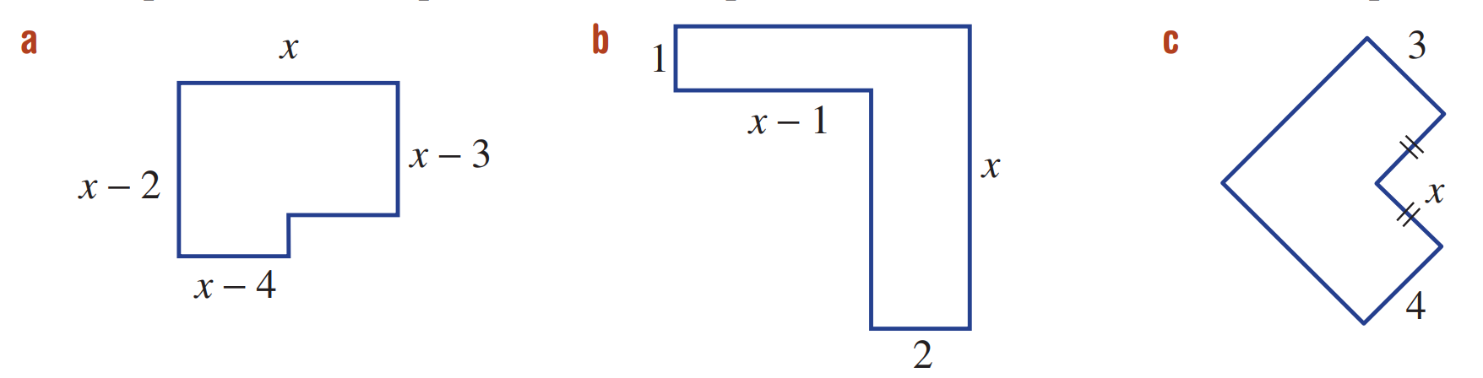  P: $4x+2$  A: $3x-1$ | P: $4x+14$  A: $7x+4$

- Expand the following. Be careful of expanding negatives.
- $5a(a-3)-2a(3a-1)$  $$=5a²-15a-6a²+2a$$  $$=-a²-13a$$ | - $4y(2y+3)-3y(y-5)$  $$=8y²+12y-3y²+15y$$  $$=5y²+27y$$

- Expand the following:
- $\frac{x}{2}\left(4x+6\right)+\frac{x}{3}(6x-9)$  $$=2x²+3x+2x²-3x$$  $$=4x²$$ | - $\frac{3a}{4}\left(8a-4\right)-\frac{2a}{3}(6a+3)$  $$=6a²-3a-4a²-2a$$  $$=2a²-5a$$
- $\frac{2x}{3}\left(3x+6\right)+\frac{x}{4}(8x-12)$  $$=2x²+4x+2x²-3x$$  $$=4x²+x$$ | - $\frac{y}{5}\left(10y-15\right)+\frac{2y}{5}(5y+10)$  $$=2y²-3y+2y²+4y$$  $$=4y²+y$$

Challenge Exercise

  - A car travels at 60 km/h for 3 hours. What is the distance travelled in the 3 hours?
$60 × 3 = 180$ km
  - A car travels at 60 km/h for $n$ hours. What is the distance travelled in the $n$ hours?
$60n$ km
  - A car travels at $x$ km/h for 3 hours. What is the distance travelled in the 3 hours?
$3x$ km
  - A car travels at $x$ km/h for $n$ hours. What is the distance travelled in the $n$ hours?
$xn$ km

  - A car travels at a constant speed for 2 hours. It travels 120 km in this time.
What is the speed of the car?
$$\frac{120}{2}= 60 km/h$$
  - A car travels at a constant speed for 3 hours. It travels $n$ km in this time.
What is the speed of the car?
$$\frac{n}{3} km/h$$
  - A car travels at a constant speed for $m$ hours. It travels $n$ km in this time.
What is the speed of the car?
$$\frac{n}{m} km/h$$
- If a car is travelling at 50 km/h, how long does it take for the car to travel $n$ km?
$\frac{n}{50}$ $h$

- For the diagram below:
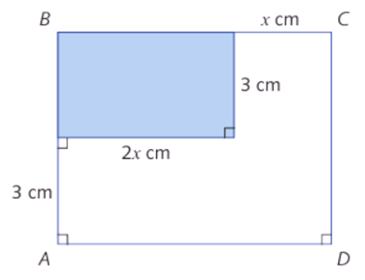

  - Find the areas of rectangle $ABCD$ and the shaded rectangle.
ABCD: $3x × 6 = 18x$ cm²
Shaded: $2x × 3 = 6x$ cm²
  - Find the difference of the two areas found in part a.
$18x - 6x = 12x$ cm²

  - A rectangle has area 56 cm² and width 7 cm. What is the length of the rectangle?
$$\frac{56}{7}= 8 cm$$
  - A rectangle has area $x$ cm² and width 3 cm. What is the length of the rectangle?
$$\frac{x}{3}cm$$
  - A rectangle has area $(x + 4)$ cm² and width 3 cm. What is the length of the rectangle?
$$\frac{x+4}{3}cm$$
  - A rectangle has area 3 cm² and width $x$ cm. What is the length of the rectangle?
$$\frac{3}{x}cm$$

  - A rectangle has area $x$ cm² and width 2 cm. What is the perimeter of the rectangle?
$$Length =\frac{x}{2}$$
$$Perimeter = 2\left(\frac{x}{2}+ 2\right)= \left(x + 4\right)cm$$
  - A rectangle has area $(x + 3)$ cm² and width 2 cm. What is the perimeter of the rectangle?
$$Length =\frac{x+3}{2}$$
$$Perimeter = 2\left(\frac{x+3}{2}+ 2\right)= \left(x + 7\right) cm$$

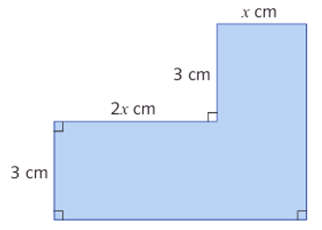
- For the shaded $L$-shaped region below, find:

  - the perimeter of the shaded region.
Perimeter $= x + 3 + 2x + 3 + 3x + 6 = (6x + 12)$ cm
  - the area of the shaded region.
Width $= x + 6,$ height $= x + 4.$
Area $= (x + 6)(x + 4)$cm²

- Think of a number. Let this number be $x$.
  - Multiply the number you thought of by 2 and subtract 5.
$$2x - 5$$
  - Multiply the result by 3.
$$3(2x - 5) = 6x - 15$$
  - Add 15.
$$6x - 15 + 15 = 6x$$
  - Subtract 5 times the number you first thought of. What is the final answer? Why is it so?
$6x - 5x = x.$
The result always equals the original number.

- Rectangle $ABCD$ is divided into four smaller rectangles by a vertical and horizontal line.
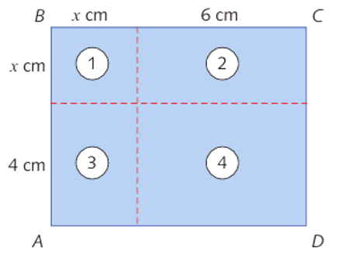
  - Find the area of each of the rectangles 1, 2, 3 and 4.

Rectangle 1: $x × x = x²$ cm²
Rectangle 2: $6 × x = 6x$ cm²
Rectangle 3: $x × 4 = 4x$ cm²
Rectangle 4: $6 × 4 = 24$cm²

  - Find the area of rectangle ABCD as a product of the lengths of its sides.

Width $= x + 6$, height = $x + 4$. Area = $(x + 6)(x + 4)$ cm²
  - Deduce that $(x + 6)(x + 4) = x² + 10x + 24$ for all values of $x$.

Sum of the four areas: $x² + 6x + 4x + 24 = x² + 10x + 24.$
This also equals the area of $ABCD = (x + 6)(x + 4).$
Therefore $(x + 6)(x + 4) = x² + 10x + 24.$
  - Find the perimeter of each of the rectangles 1, 2, 3 and 4.

Rectangle 1: $4x$ cm
Rectangle 2: $2(6 + x) = (12 + 2x)$ cm
Rectangle 3: $2(x + 4) = (8 + 2x)$cm
Rectangle 4: $2(6 + 4) = 20$cm
  - Find the perimeter of rectangle $ABCD$.

$2((x + 6) + (x + 4)) = \left(4x + 20\right)$ cm

- The area of rectangle $ABCD$ is 16 cm². The length of BA is $x$ cm.
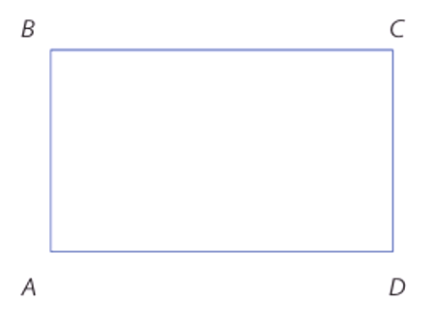
  - Find the length of $BC$, in terms of $x$.

$$BC =\frac{16}{x}$$

  - Write down an expression for the perimeter of the rectangle, in terms of $x$.

$$2\left(x +\frac{16}{x}\right)= \left(2x +\frac{32}{x}\right)$$
  - If $x = 4$, find the perimeter of the rectangle.

$$2\left(4\right)+\frac{32}{4}= 16 cm$$
  - If $x =$ $\frac{1}{4}$, find the perimeter of the rectangle.

$$2\left(\frac{1}{4}\right)+\frac{32}{\frac{1}{4}}=\frac{1}{2}+ 128 = 128½ cm$$

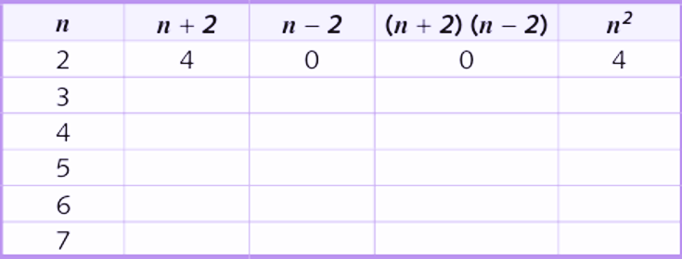
  - Fill in this table.

  - Deduce that $(n + 2)(n - 2) = n² - 4$ for $n = 2, 3, 4, 5, 6$ and $7$.

In each row, $(n + 2)(n - 2) = n² - 4$. This holds for all values listed.
  - Why does $n² - 4 = (n + 2)(n - 2)$ for all whole numbers n?
$$\left(n + 2\right)\left(n - 2\right)$$
$$= n\left(n - 2\right)+ 2\left(n - 2\right)$$
$$= n^{2}- 2n + 2n - 4$$
$= n² - 4.$
Therefore $n² - 4 = (n + 2)(n - 2)$ for all whole numbers $n.$

- Write an algebraic expression for each of the following:
  - Find the area of the square whose perimeter is $12d$ cm.
$$Side =\frac{12d}{4}= 3d$$
$$Area = {\left(3d\right)}^{2}= 9d^{2} {cm}^{2}$$
  - Find the area of a rectangle whose perimeter is $32k$ cm and whose length is three times its width.
$$Let width = w, so length = 3w$$
$$2\left(w + 3w\right)= 32k$$
$$w = 4k$$
$$Area = 3(4k)(4k) = 48k² cm²$$
  - Find the equal length of an isosceles triangle whose perimeter is $k$ cm and base $d$ cm.
$$2l + d = k$$
$$l =\frac{k - d}{2}cm$$
  - Find the width of a rectangle whose perimeter is $k$ cm and length $d$ cm.
$$2\left(w + d\right)= k$$
$$w =\frac{k - 2d}{2} cm$$
- If $x = 2y$ and $y = 3z$ express:
  - $x + 3y - 7z$ in terms of $z$
$$Sub x = 6z, y = 3z:$$
$$6z + 9z - 7z = 8z$$
  - $x + 3y - 6z$
    - in terms of $y$
$$Sub x = 2y, z =\frac{y}{3}:$$
$$2y + 3y - 6\left(\frac{y}{3}\right)= 3y$$
    - in terms of $x$
$$Sub y =\frac{x}{2}, z =\frac{x}{6}:$$
$$x + 3\left(\frac{x}{2}\right)- 6\left(\frac{x}{6}\right)=\frac{3x}{2}$$
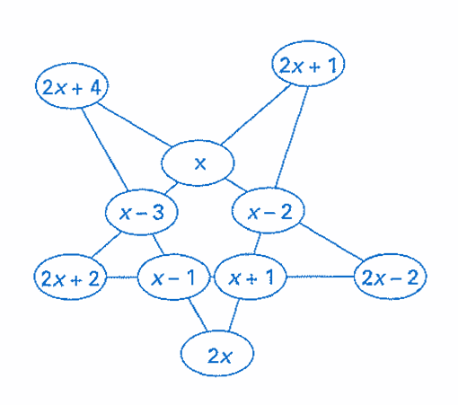
- Place the following algebraic expressions in the ovals so that four ovals in a row total $6x$.
$$x-3, x-2, x-1, x, x+1$$
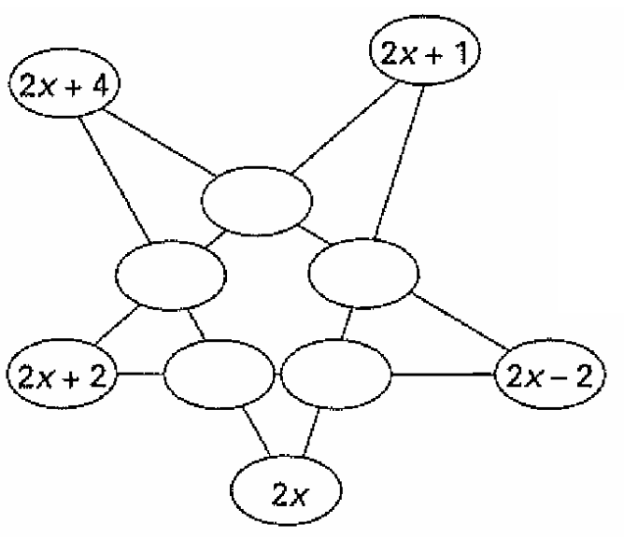

- A car travels 20 km from Cranung to Doville.
It travels $d$ km at 60 km/h and the remainder at 80 km/h.
  - How far does the car travel at 80 km/h?
$$\left(20 - d\right) km$$
  - For how long, in terms of $d$, does the car travel at:
    - 60 km/h?
$$\frac{d}{60} h$$
    - 80 km/h?
$$\frac{20-d}{80} h$$
  - What is the total time for the journey, in terms of $d$?
$$\frac{d}{60}+\frac{20-d}{80}$$
$$=\frac{4d + 3\left(20-d\right)}{240}$$
$$=\frac{d + 60}{240}h$$
  - Find the total time taken, in minutes, if:
    - $d = 6$ km
    - $d = 12$km
    - $d = 20$ km

$$Convert to minutes:\frac{d + 60}{240}× 60 =\frac{d + 60}{4} min$$
$$i.\frac{6 + 60}{4}= 16½ min$$
$$ii.\frac{12 + 60}{4}= 18 min$$
$$iii.\frac{20 + 60}{4}= 20 min$$

  - If a is a whole number, what are the possible last digits of $a²$?
(For example, if $a$= 87, the last digit is 9.)
Possible last digits of $a²$: $0, 1, 4, 5, 6, 9.$
  - If $a$ is an even number, what are the possible values of the last digit of $a² + 1$?
(For example, if $a$ = 86, the last digit of $a² +$ 1 is 7.)

For even a, last digit of $a$ is 0, 2, 4, 6, or 8.
Last digits of $a²:$ 0, 4, 6, 6, 4.
Adding 1: 1, 5, 7, 7, 5.
Possible last digits of $a² + 1$: 1, 5, 7.
  - If $b$ is an even whole number divisible by 3, what are the possible last digits of $b$?
$b$ is even and divisible by 3, so $b$ is divisible by 6.
Last digits of multiples of 6 cycle through: 6, 2, 8, 4, 0.
Possible last digits: 0, 2, 4, 6, 8.

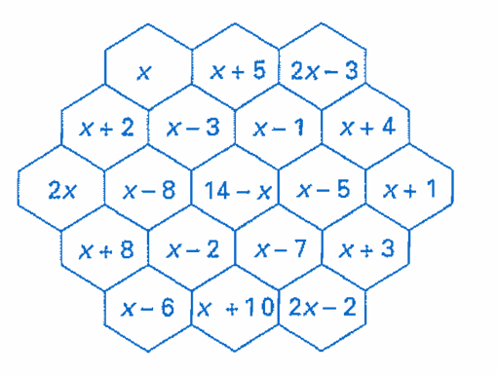
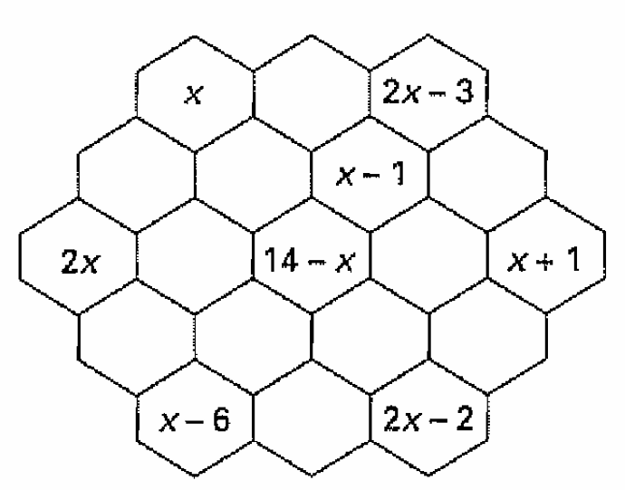
- Complete the hex grid so that any straight-line sums to $4x+2$.

- Expand each of the following:
  - $2\left(3\left(4\left(5x + 2\right)+ 3\right)+ 4\right)+ 5$

$$120x + 79$$
  - $-2\left(-3\left(-4\left(-5x - 2\right)- 3\right)- 4\right)- 5$

$$120x + 33$$
  - $4\left(3\left(2\left(x + 2\right)+ 2\right)+ 3\right)+ 4$

$$24x + 88$$
  - $-4\left(-3\left(-2\left(x - 2\right)- 3\right)- 4\right)$

$$-24x + 28$$

- Write an expression for the following, then expand to show it always equals the same thing.
- Think of a number.
- Add 3 to your number.
- Multiply your answer by 2.
- Subtract twice your original number.
- Multiply your answer by 7.

For any initial value $x$, we get the expression $7\left(2\left(x+3\right)-2x\right)$.
$$=7\left(2x+6-2x\right)$$
$$=7\left(6\right)$$
$$=42$$

